RULES AND SCHEME OF BBA, B.Vov (ATA), B.Com. (Hons.) ENTRANCE TEST-2026
1. Date of Examination : 22/06/2026 (Monday)
Time : 11.00 AM to 01.00 PM
Venue : University College of Commerce & Management Studies,
MB Campus, Opp. Hotel Raghu Mahal, Kumharon Ka Bhatta, Udaipur.
2 Exam Mode: Examination will consist of multiple choice questions (Objective) Candidates must note that the exam will be conducted in English Medium.
3. Duration: Exam will be conducted for duration of two hours (120 minutes).
4. Number of Questions: Candidates will have to attempt a total of 100 objective type questions.
5. Marking Scheme: Exam will carry a total of 100 marks with each question carrying 1 mark. Each correct answer will be given 1 mark while for incorrect answer 0 marks will be awarded. Candidates must note that if a question is marked with multiple answers the answer will be considered as incorrect and 0(zero) marks will be awarded for the same.
6. There will be no negative marking.
BBA Entrance Test Pattern:
Section | Subject | Distribution of Marks/No. of Questions
A | GENERAL KNOWLEDGE | 25
B | CURRENT AFFAIRS | 25
C | GENERAL ENGLISH | 25
D | MATHEMATICS | 25
Total |  | 100

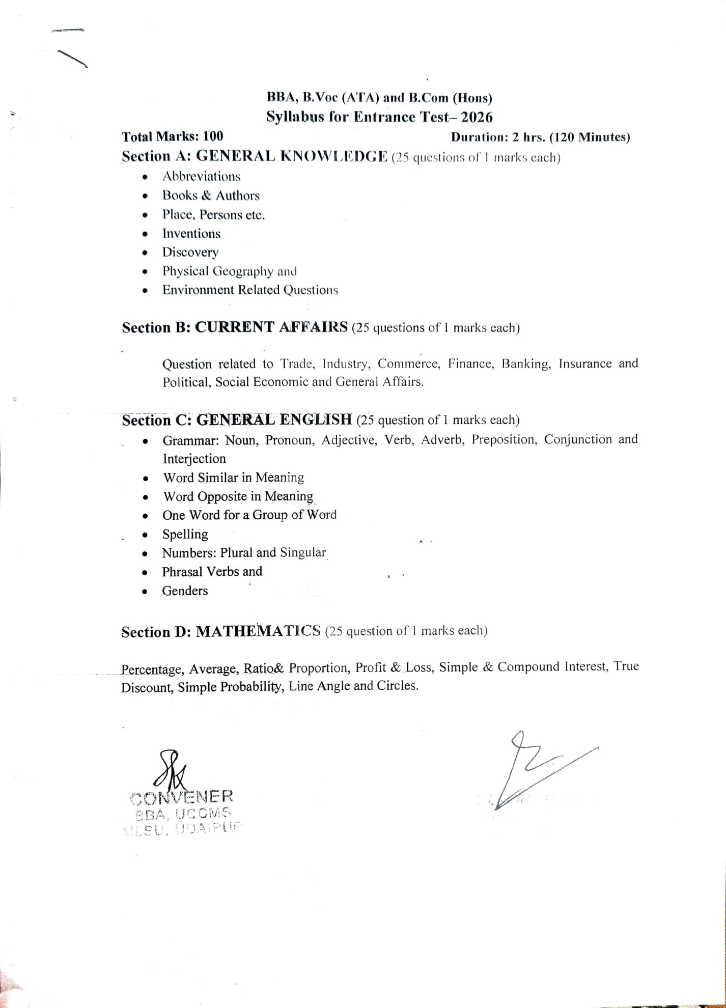
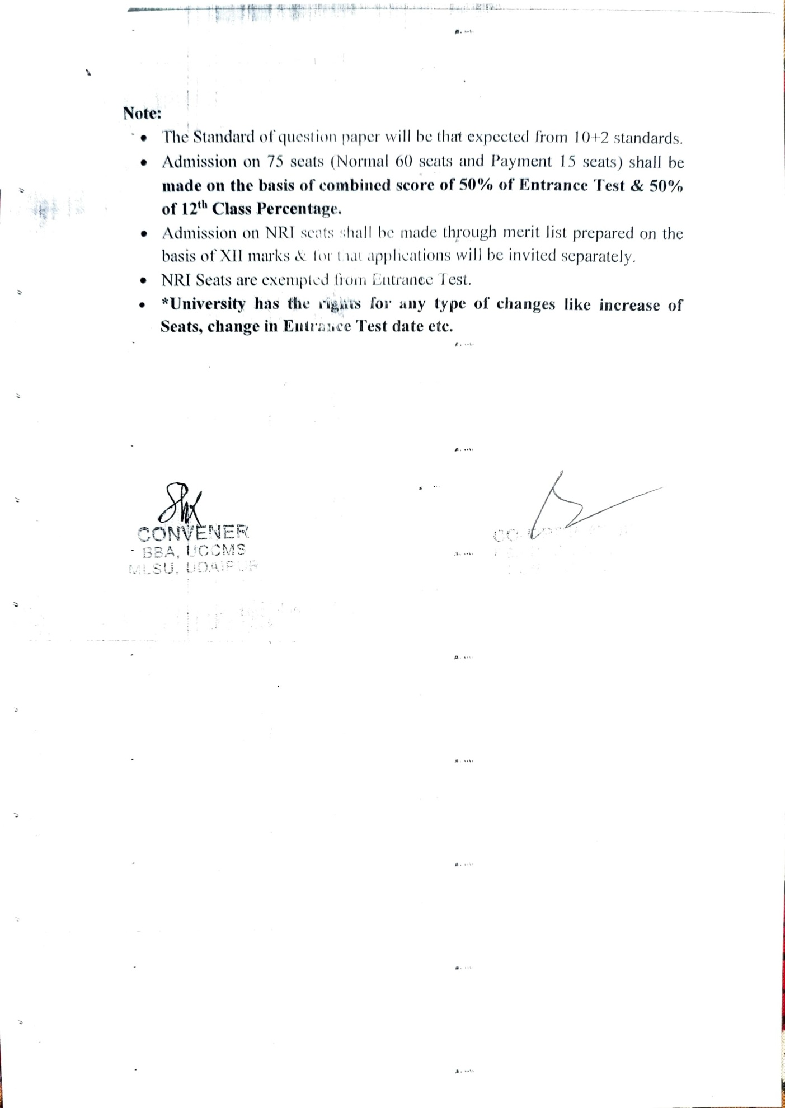
MODEL QUESTION PAPER
(AN ENTRACT)

Section A
GENERAL KNOWLEDGE
Q.1. The name ‘South Rodesia’ is associated with which of following Country
(a) Namibia (b) Zambia
(c) Zimbave (d) South Africa ( )
Q.2. Which continent is also called ‘Dark Continent’
(a) Africa (b) Asia
(c) Australia (d) Antarctica ( )
Q.3. Who is the author of the book ‘Ignited Mind’
(a) SalmanRushdi
(b) V.S. Niapaul
(c) Khuswant Singh
(d) Dr. A.P.J. Abdul KalamAjad ( )
Q.4. Who is author of ‘My Impossible Children’
(a) SavrinoAntinory (b) BrigidBassilior
(c) TaslimaNasreen (d) Azra Akin ( )
Q.5. Which the following is also called ‘Sugar Bowl’
(a) Combodia (b) India
(c) Malaysia (d) Cuba ( )
----- -----------------------------------
----- -----------------------------------
Q.25. Which unit of valuation is known as ‘Paper Gold’
(a) Euro Dollar (b) Petro Dollar
(c) SDR (d) GDR ( )

Section B
CURRENT AFFAIRS
Q.26. What is the expansion of ‘BPO’
(a) Bharat Petro Organisation
(b) Business Process Outsourcing
(c) Business Planning and Operation
(d) None of the above ( )

Q.27. Who is the President of ‘Women Commission?’
(a) Ms. Mamta Sharma
(b) Ms. Lalitha Kumara Mangalam
(c) Dr. GirijaVyas
(d) Ms. Rekha Sharma ( )
Q.28. Up to what extent investments are exempted to the individual assesse as per finance bill
2015
- 90,000 (b) 1,00,000
(c) 1, 50,000 (d) 2,00,000 ( )
Q.29. Donald Trump elected as Presidential Candidature belong to
(a) Conservative Party
(b) Liberal Party
(c) Republic Party
(d) Democratic Party ( )
Q.30. World ‘International Yoga Day’ is Celebrated on
(a) 21st April
(b) 21st May
(c) 21st June
(d) 21st July ( )
----- ----------------------------
----- ----------------------------
Q.50. Phukan Commission was formed to look into the matter of:
(a) Defense Deal
(b) Disinvestment
(c) Fooder Scam
(d) None of the above ( )

Section C
ENGLISH
Direction: In question No. 51 to 55 out of the four alternatives choose the one which best expresses the meaning of the given word
Q.51. Amicable
(a) Poisonous (b) Friendly
(c) Satisfying (d) Heartening ( )
Q.52. Prudent
(a) Skilled (b) Experienced
(c) Cautious (d) Criminal ( )
Q.53. Vindicate
(a) Open (b) Ventilate
(c)Justify (d) Recommend( )
Direction: In question No. 56 to 60 of the four alternatives choose the one that has most opposite meaning
Q.56. Omit
(a) Exclude (b) Include
(c) Contemplate (d) Segregate ( )
Q.57. Transparent
(a) Clear (b) Ambiguity
(c) Opaque (d) Crystal ( )
----- ----------------------------
----- ----------------------------
Q.75. ______________ gambling is a common antisocial behavior, which has very little
_____________ social value
(a) Occasional ……………….. Remedy
(b) Pathological ……………... Redeeming
(c) Saturnine ………………. Redress
(d) Frequent ………………. Rectification ( )

Section D
MATHEMATICS
Q.76. If 11% of a number exceeds 7% of the same by 18, , the no.
(a) 72 (b) 360
(c) 450 (d) 720 ( )
Q.77. The price of an item is increased by 20% and then decreased by 20%. The final price as
Compared to original price is
- 20% less (b) 20% more
(c) 4% more (d) 4% less ( )
Q.78. If A’ is 25% more than B’s income is20% more than C’s by what percent is A’s income
more than C’s
- 15% (b) 25%
(c) 33^{1/2%} (d) 50% ( )
Q.79. What is the ratio whose terms differ by 40 and the measure of which is 2/7?
(a) 16:56 (b) 14:56
(c) 15:56 (d) 16:72 ( )
Q.80. The average of 6 number is 30. If the average of first four is 25 and that of the last three
is 35, the fourth number is
- 35 (b) 30
(c) 25 (d) 40 ( )
----- -------------------------------
----- -------------------------------
Q.100. In a simultaneous throw of two dice, what is the probability of getting a total of 7?
(a) 1/6 (b) 7/12
(c) 7/36 (d) 7/4 ( )

********

